

Arbid Chowdhury

Pokémon Project Report

Background

The Pokémon TCG game java edition is created to allow users to play the Pokémon battle simulating actual card game played by people worldwide. The game contains the basic game flow of the card game and allows users to battle another player through the java terminal. This game program helps the users get a general understanding of the card game, experiment with different turn options, and overall build game strategy when applying experience from program to actual card game battle. The program covers the basic game flow and contains various energy types, attack amplification or weakening, and evolutions to better inform user of actual game battles and how card selection can affect the game. The essential objective of this program is to create a playable version of the card game utilizing OOP and other concepts learned throughout the years and to allow users to learn more about Pokémon TCG.

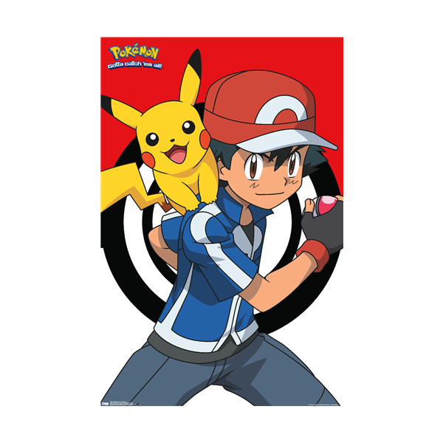

Game Flow

The Pokémon TCG program follows the same game flow as the actual card game to provide realistic gameplay. The game flow consists of two players having shuffled decks which they draw their 7-card hand from unless if there are no basic Pokémon in hand then player reveals hand, puts hand back in deck, shuffles deck, and redraws until hand contains one. If the player redraws then opposing player draws 1 card for each redraw. When both players have proper hands, they draw their 6-card prize piles which will be incrementally be earned as Pokémon are defeated in battle. The players then flip a coin to see which player goes first and sets their field first. The field setup is the prerequisite to the battle, in which players must place 1 Pokémon in Active and optionally add up to 5 Pokémon on their bench. After the players setup their field, the game begins with winner of coin flip getting the first turn.

The Turn flow for players begins with drawing a card once, which must be completed before ending turn, then followed by the player turn options. Players can either activate a Trainer, attach an Energy, place Pokémon, swap/retreat Pokémon, or evolve Pokémon. These options are entirely optional but recommended to be utilized by player to advance gameplay intricacy and increase their strategic skill building. The final option is to pass the turn which requires player to have drawn the card once in the turn. When the player attacks with their Active, if required energy is attached for specific attack type, then damage is done to opposing Active effectively ending the player’s turn.

The Win Conditions are very important in the game and must be kept in thought process during the turn, otherwise player could lose soon after. The first condition is to retrieve all 6 of your prize pile cards, which is done by defeating 6 of the opposing player’s Pokémon. Each Pokémon defeated allows the player to retrieve one prize card from their pile to their hand for use in future turns. The second condition is to have opponent run out of cards in their deck, which would not allow the opponent to draw. The third condition is to defeat the opponent’s Active and if the opponent’s bench is empty, the empty field causes the player to win the game. Players must keep these conditions in their strategic turns in order to overcome the odds to defeat the opposing player.

The Pokémon TCG program has many factors that player must keep in mind such as how different Pokémon types are stronger/weaker to other types, ensuring the correct Energy is applied to their Pokémon, and evolving Pokémon within their evolutionary line. With all these factors, players can clearly understand the game process by viewing the Game Structure section, with visual cues on what to do and what not to do.

Game Structure

The TCG program begins with displaying the starting game menu which contains 4 options. The options are Start Game, Learn Game Rules, Display Standard Game Deck, and Exit Game and are selected by entering the assigned number next to the option.

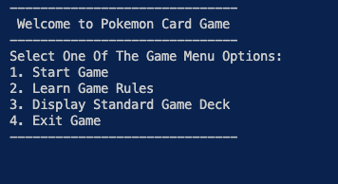

Before the explanation of the game structure, the other options when selected display the following:

**Learn Game Rules**

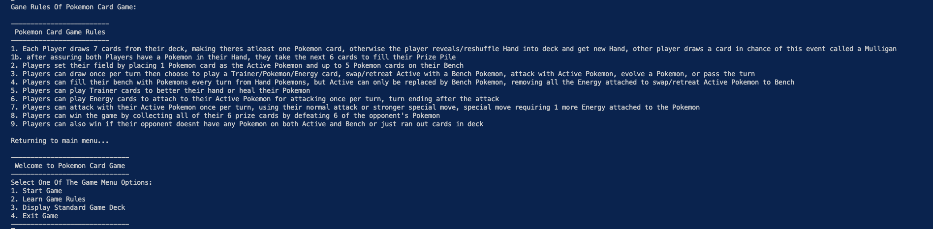

**Display Standard Game Deck**

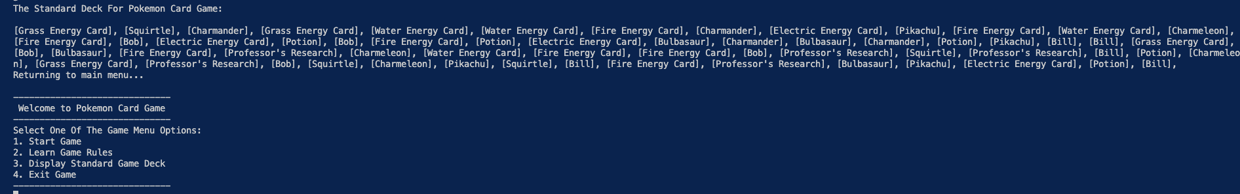

**Exit Game**

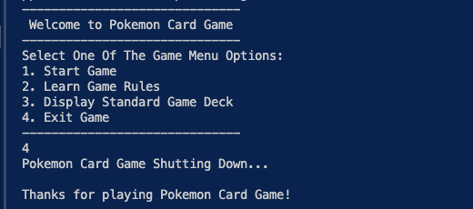

Moving on to the Game Structure of the Pokémon Battle which is where the players will set their fields and battle with their Pokémon. The battle requires the players to be setup and coin flip done to determine which player gets the first turn/field setup. Starting with the player setup which asks both players to enter their names, thus generating their decks, and flipping coin to see which player sets their field up first. By entering 0 for heads or 1 for tails, the coin is flipped, and the field setup begins for the winner of the flip.

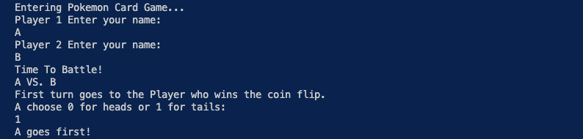

Invalid Input (Not 0 or 1)

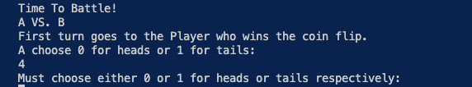

Before the coin flip, the players’ decks, hands, and prize piles are generated after players input their names. However, if the hand lacks any basic Pokémon, then the player’s hand is revealed, shuffled back into the deck, and redrawn. If this event occurs, known as a Mulligan, then the opposing players draws one extra card for their hand.

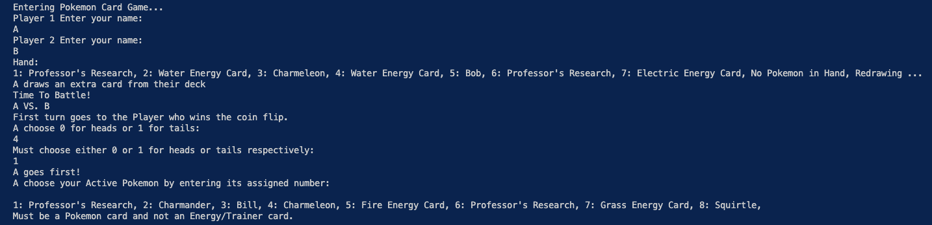

As visualized, Player B reveals their hand due to lack of basic Pokémon, redraws their hand, and Player A draws an extra card. That extra card is added to A’s hand as seen in the beginning of the field setup.

Next for the players is the field setup, which is where both players select an Active Pokémon and can place up to 5 Pokémon on their benches. This process displays the Players hands with assigned numbers for selection and the hand updates upon selection. The field setup for both Active Pokémon and bench check for correct input, blocking out non-Pokémon card types, and provides an exit for bench selection if player does not want to add to bench.

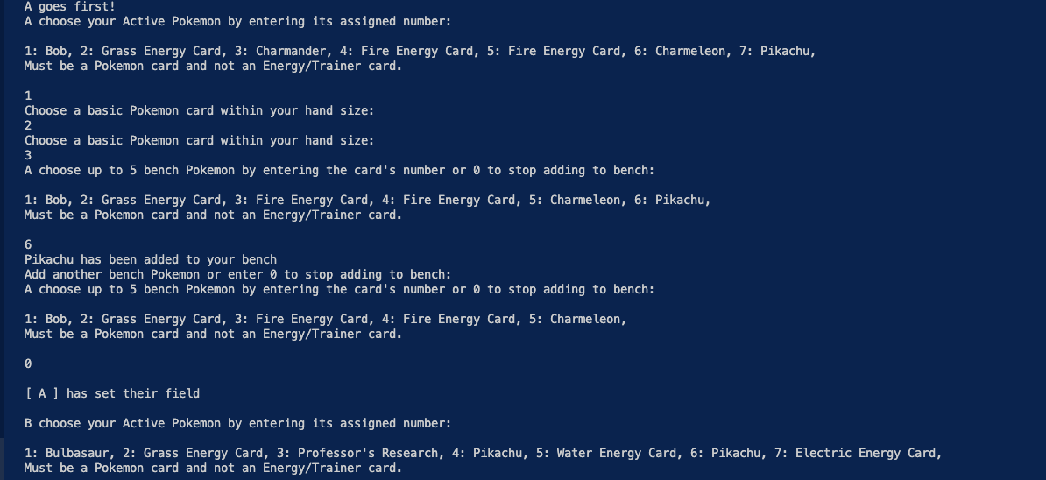

After both players have set their fields, the Pokémon Battle officially begins with the coin flip winner going first. Below is the Game field which changes to the perspective of the current player’s turn.

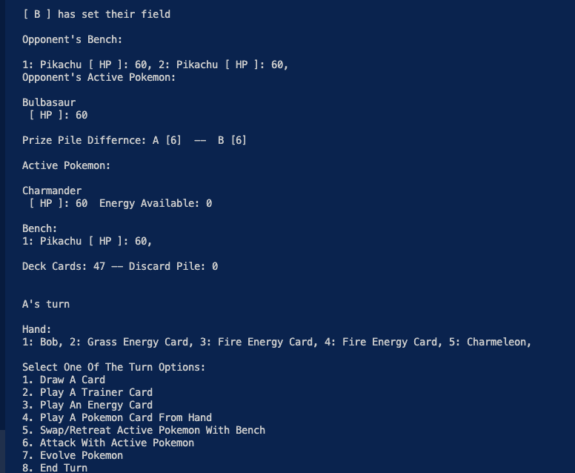

The majority of game structure is the turn system which allows players to draw a card, activate a Trainer, attach an Energy to Active, Place Pokémon on bench or Active, Swap/Retreat Active with bench, Attack opposing Active, Evolve Pokémon on bench or Active, or to End turn. Out of all 8 options, Attacking and Ending turn cannot be done without drawing a card before selecting the respective option. Drawing a card is mandatory, once per turn maximum, and the change is reflected in the hand display on game field.

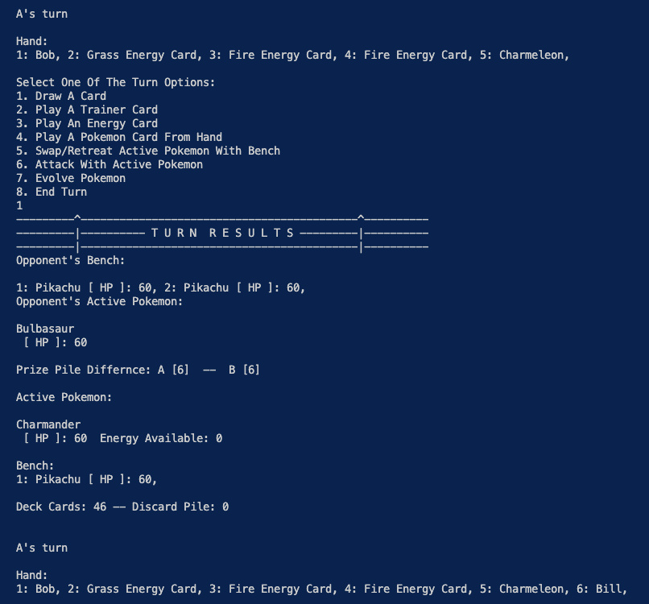

Following this draw, turn options 6 and 8 are open to be used by player but using the other options are in the player’s best strategic interest. The Trainer and Energy options works very similarly, both assuring only their respective card types are selected and offering player option to exit by entering 0. The Trainer activation has different effects depending on Trainer selected, during this turn player will use Bill to draw 2 cards.

When attaching an Energy, only available for Active currently, the type must match the Active’s type which in this turn would be Fire Energy Card for Charmander. When you successfully attach the Fire Energy, which is only once per turn, this opens the possibility of making Active Pokémon attack or Swap/Retreat with a Pokémon from the bench. Swapping requires one Energy to complete swap and the Normal attack for basic Pokémon like Charmander requires one Energy. Swapping also removes all the Energy that was attached to the previous Pokémon that was just benched.

**Activating Trainer**

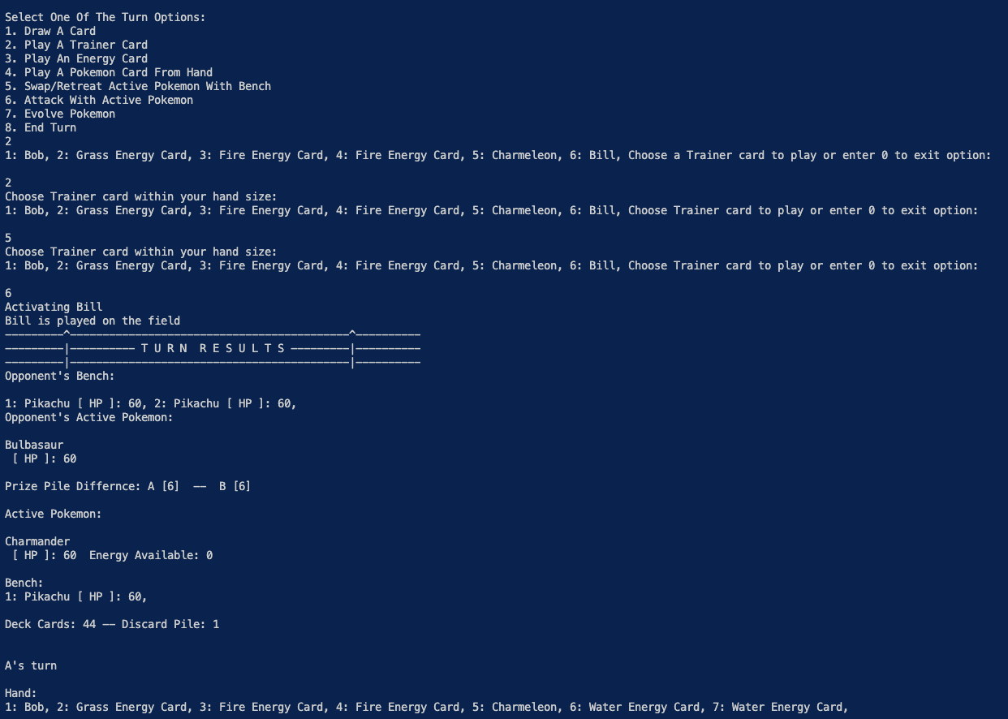

**Attaching Energy**

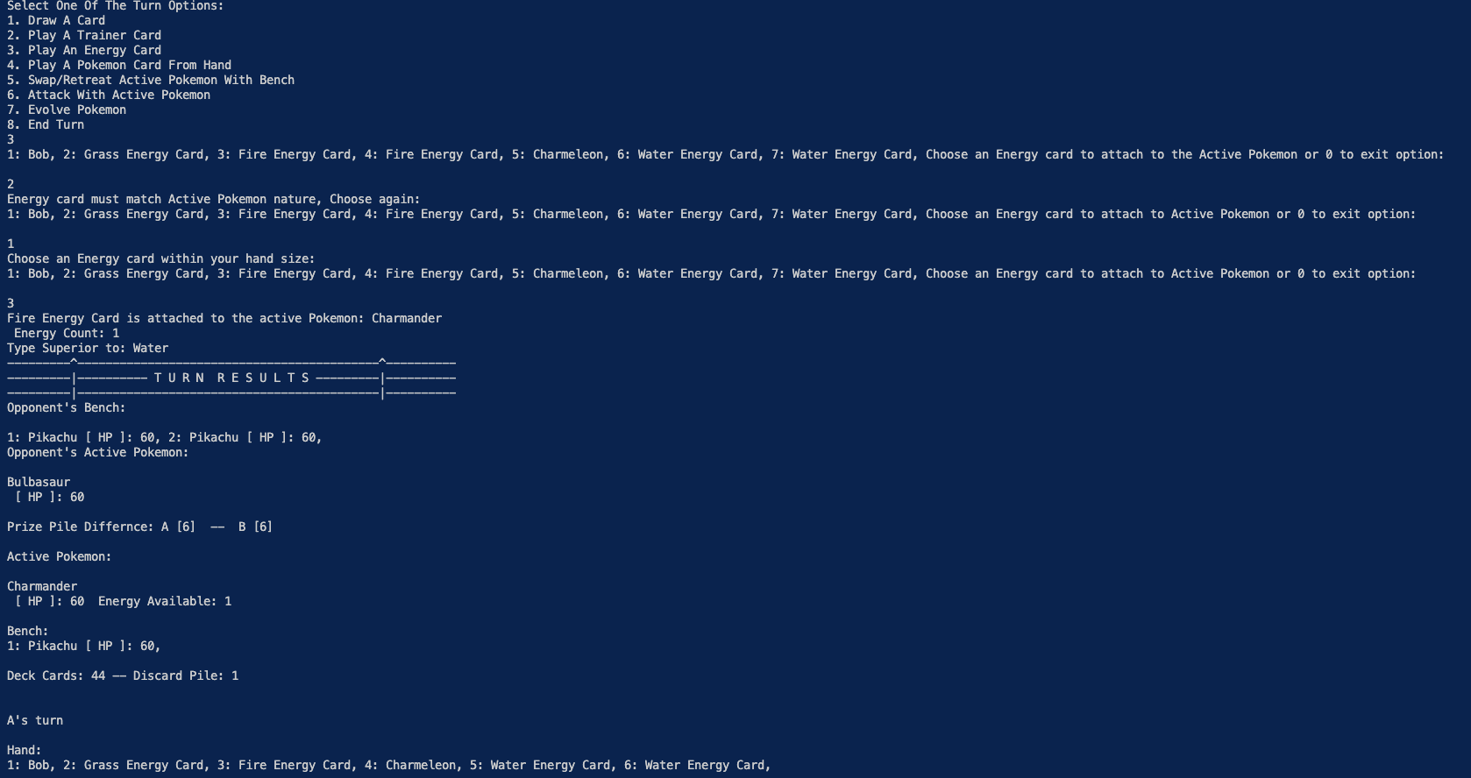

**Swapping/Retreating Active**

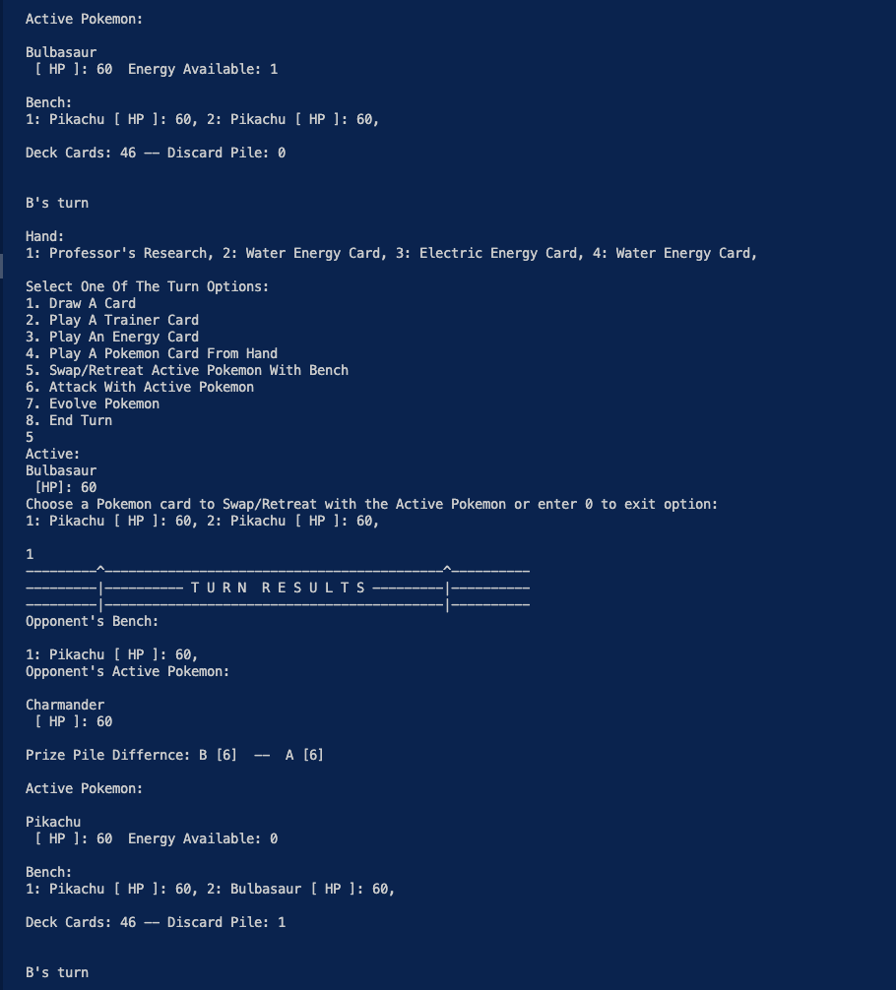

The Swapping above is done by Player B, which is a move usually done to prevent Pokémon from being defeated, blocking opposing player from retrieving a prize card. The next turn option to explore is the Place Pokémon option which lets player place a Pokémon from hand to either bench or Active, if it has enough space. The Active being full directs player to using the Swap/Retreat feature to remove Active if necessary. Placing a Pokémon can be done multiple times per turn and is visualized below.

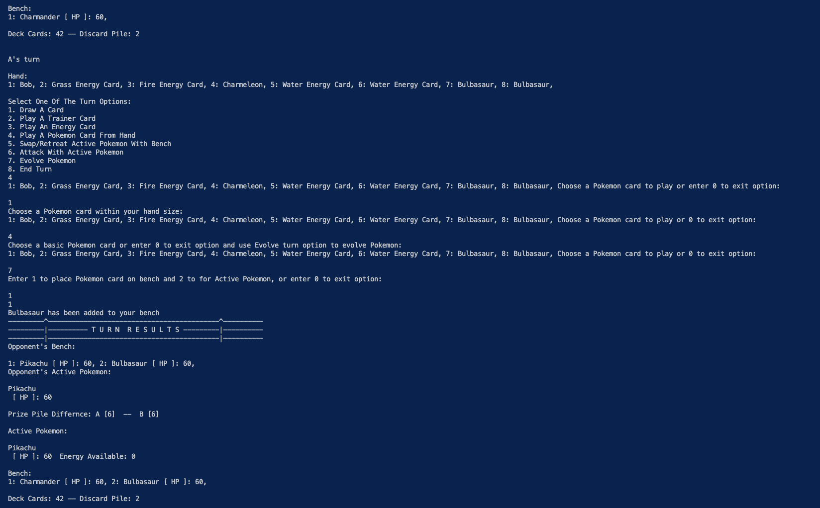

The Placement of Pokémon is essential in evading the loss condition of having an empty field, due to how when an Active Pokémon is defeated the first in bench is automatically added to Active to prevent loss at the beginning of turn. Next turn option would be the Evolve Pokémon which allows player to evolve Active or bench Pokémon, if the chosen Pokémon is part of the Pokémon line. The evolution for Active can be observed in the visualization below.

**Active Evolution**

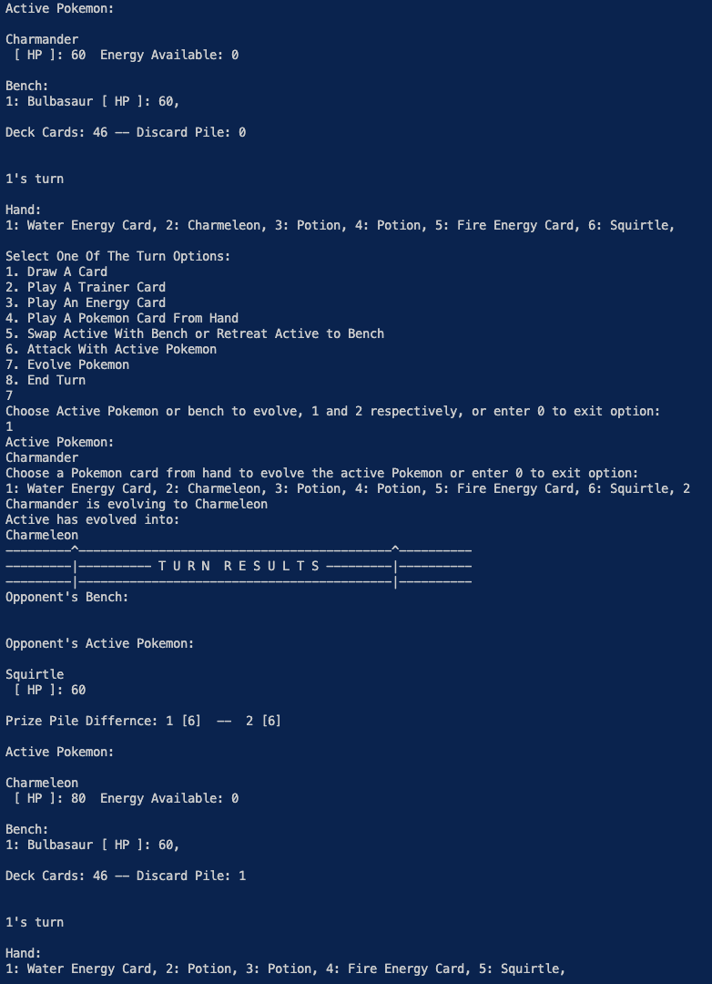

**Bench Evolution**

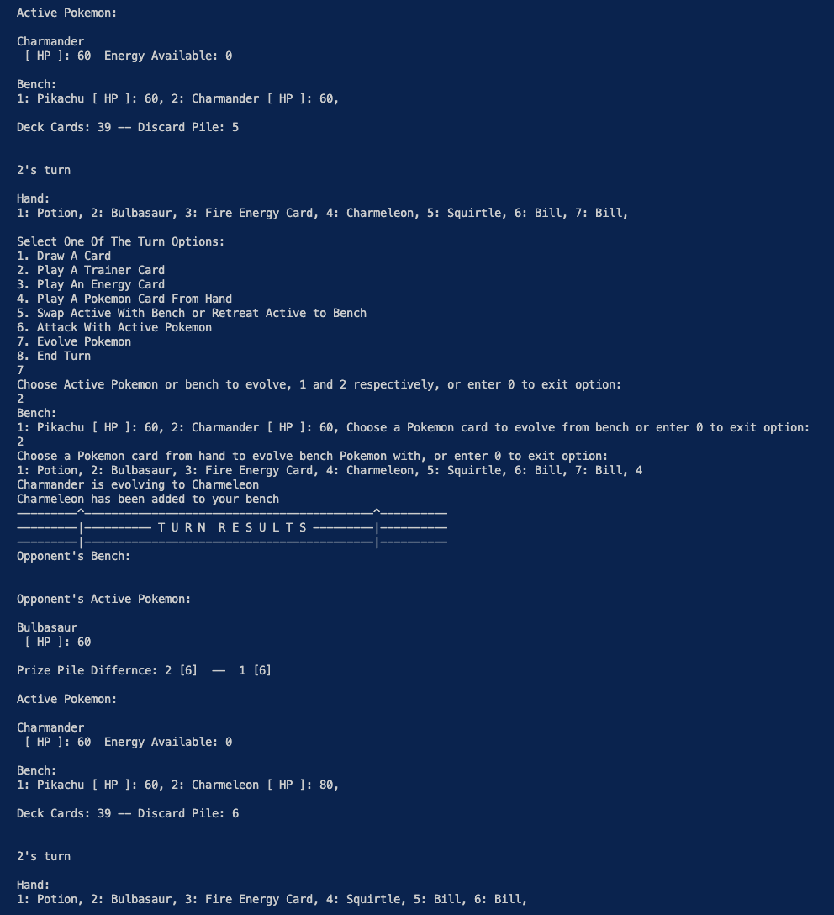

The Evolution turn option above is used to defeat enemy Pokémon faster to collect the prize cards faster. The bench can be evolved the same way by entering 2 instead of 1 shown in the visualization. Next turn option is Attacking which has 3 factors, Energy required, Pokémon damage boost/weakening, and Evolved Active status. Attacking also requires both players to have filled Active spots otherwise players cannot attack during their turn. The Energy required is 1 for Normal Attack and 2 for Special Move which changes if the Pokémon is evolved. If evolved, then the Active requires 1 more energy for each of the attack choices. Players must also keep in mind which Pokémon types are superior or weaker to others, when attaching Energy cards players can see what type their Active is better than. Below is a visualization of Attacking with the player’s Active Pokémon.

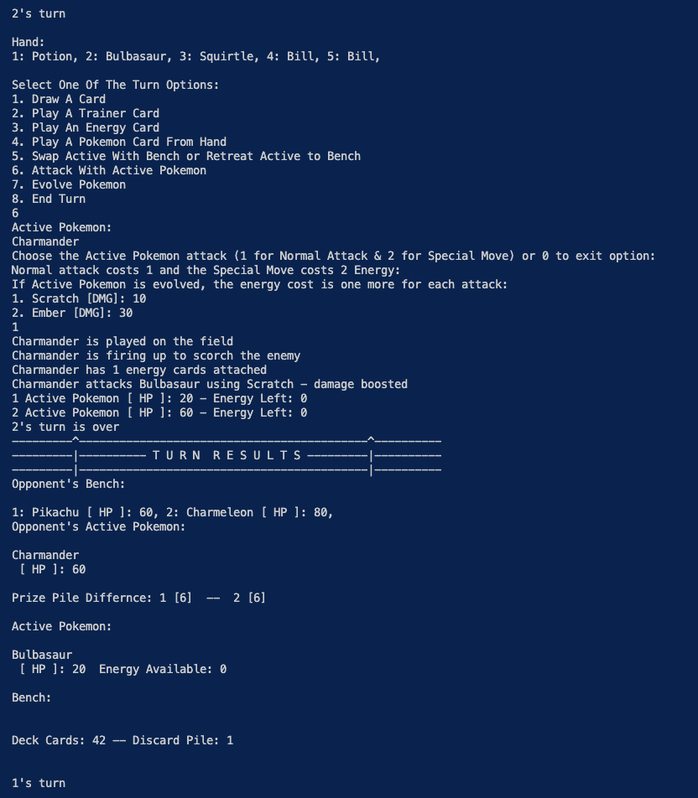

The Attack phase has exit option and assures if player attacks without energy, their turn continues until they attempt another attack or pass turn. Attacking informs player of damage dealt, any type of effect on damage, and both Active’s statuses. When attacking with an Evolved Active, the program checks if the energy is increased and if not, the turn continues due to failed attack. The final option is to pass the turn which cannot be done without drawing card as visualized below.

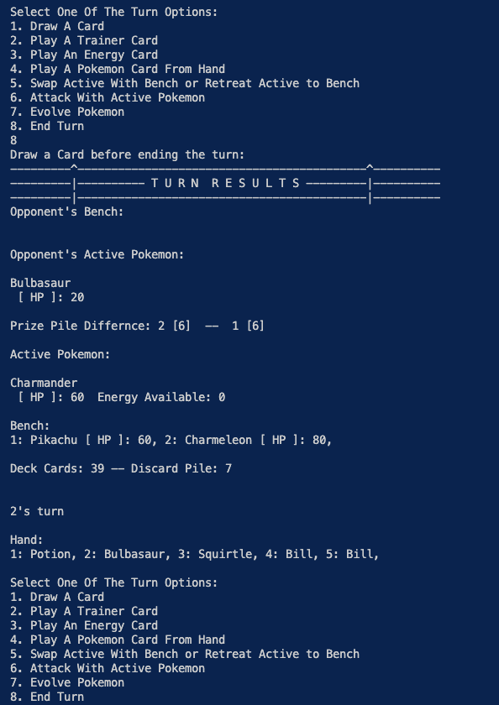 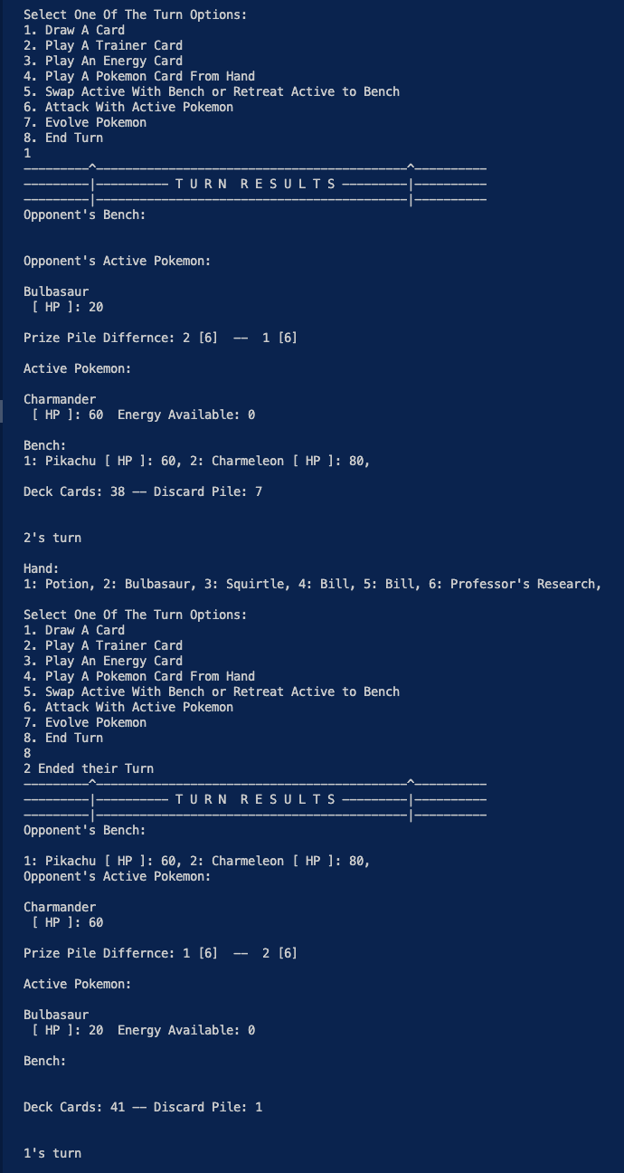

Win Conditions

The Pokémon Battle program, as previously explained, contains 3 different win conditions that allow a player to beat another player. The first one is the main condition which is to beat 6 of opposing player’s Pokémon to retrieve all 6 prize pile cards. The second is to have opposing player run out of all their cards in deck, which would allow them to draw once per turn. The third condition is to defeat the opposing player’s Active, and the player has 0 Pokémon on their bench. Below is a visualization of condition 3 and part of condition 1 with a prize card being earned by player.

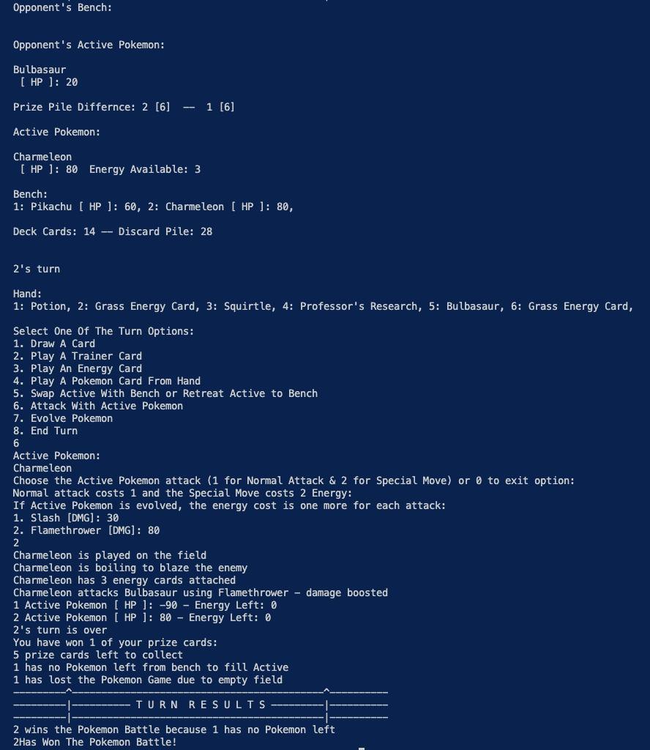

**Taking Prize Card**

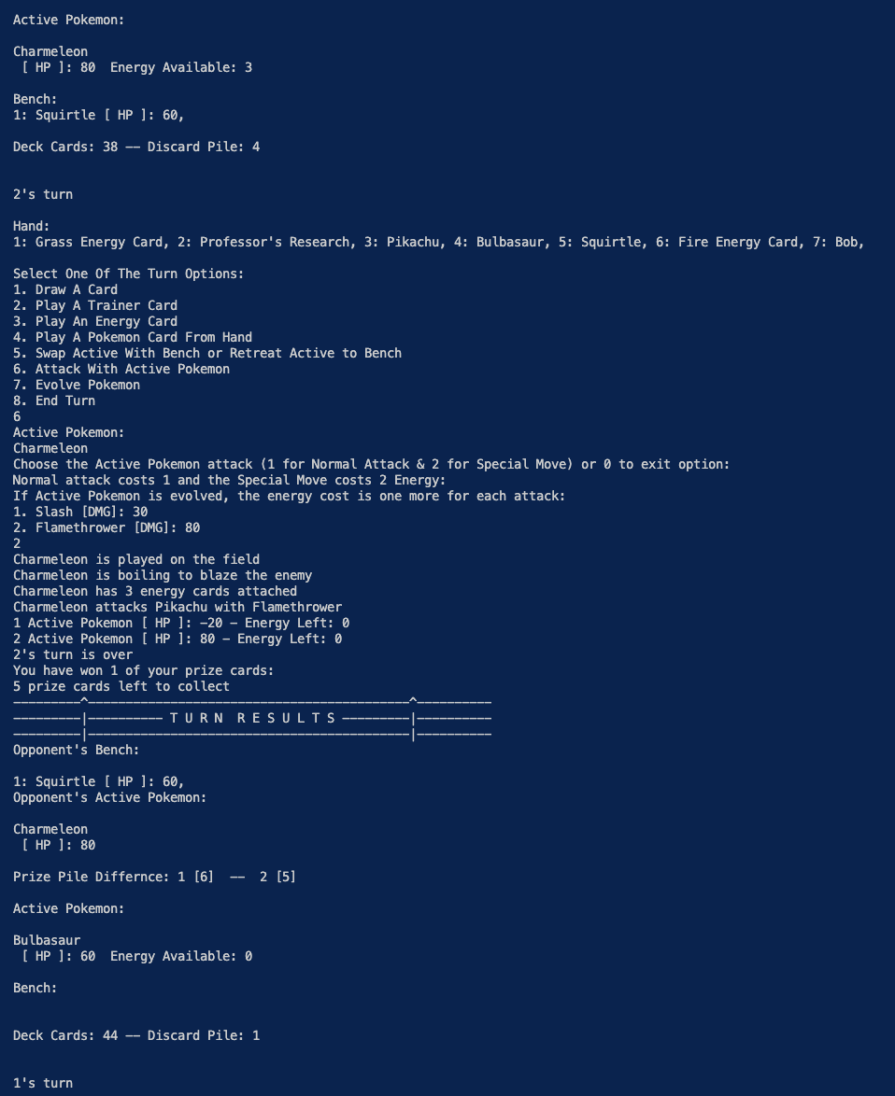

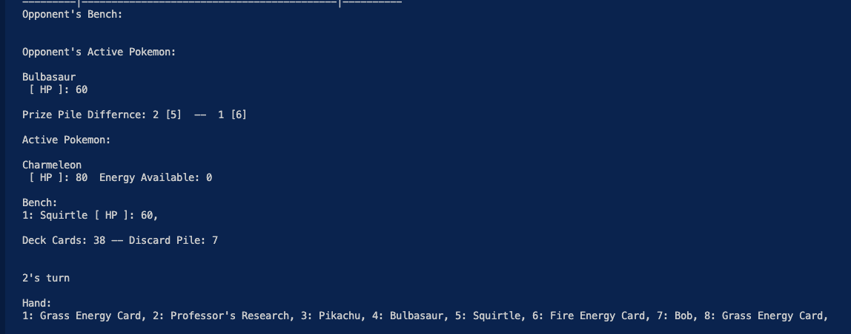

**Winning All Prize Cards**

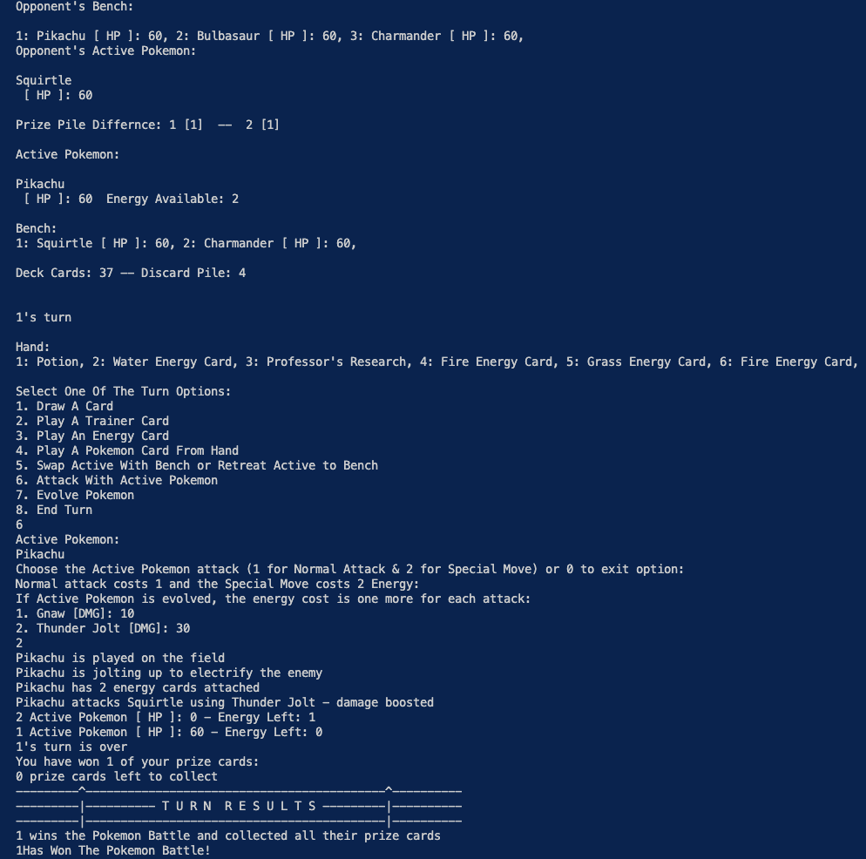

**Opposing Player Can't Draw**

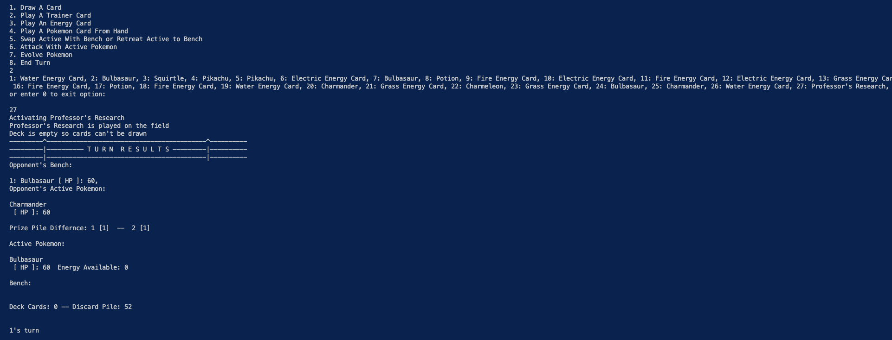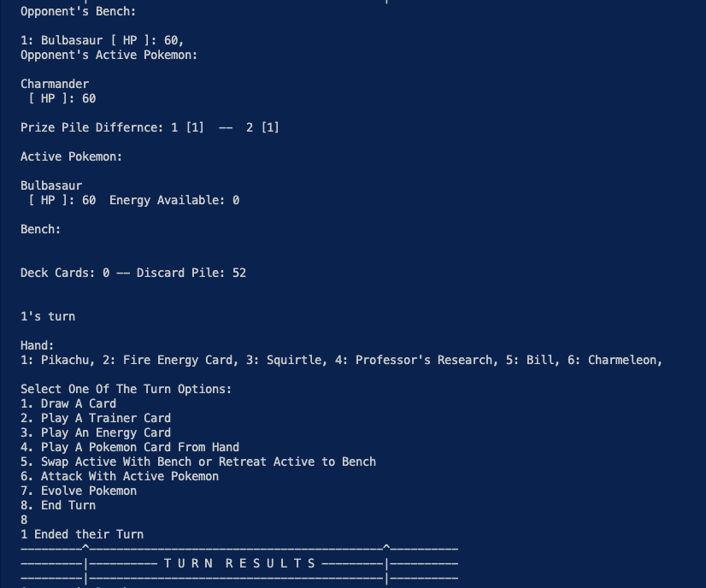

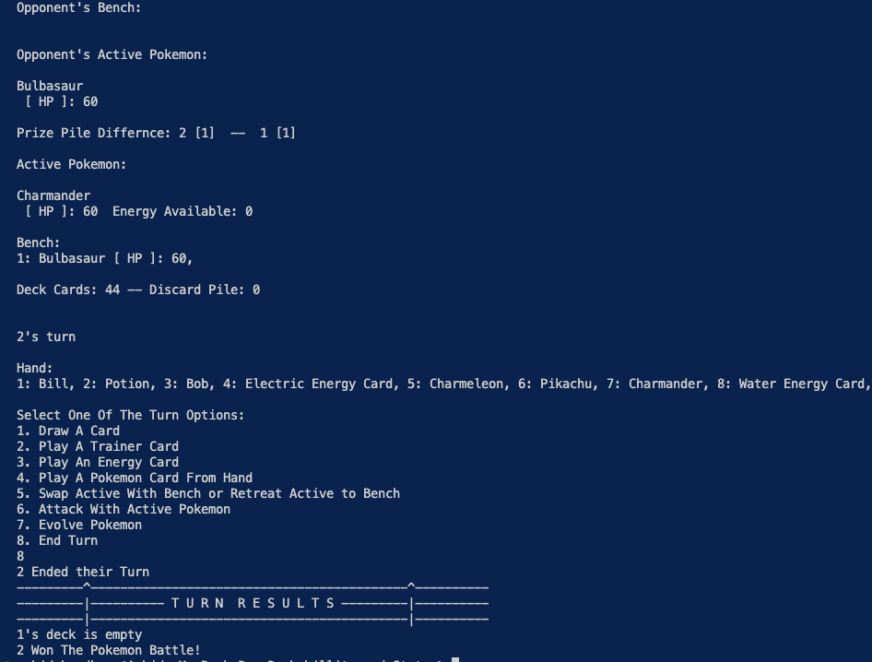

Program Details

The Pokémon TCG Battle program is comprised up of 27 files which can split into categories such as Pokémon, Trainer, Energy, Player, etc. The Card java file is the superclass which has subclasses Pokémon, Trainer, and Energy. These subclasses utilize the common attribute of CardName and use the CardGuide interface. This interface houses the playCard method which is overridden by each subclass to display what card is being played during turns. Following that is the TrainerCard java file which also implements the TrainerGuide interface to activate Trainer power during turns. Trainer is a superclass to all Trainer Cards (Bill, Bob, UltraPotion, Professor’s Research). These cards override the activate Trainer ability to complete each unique card effect such as Bill drawing 2 cards to hand and Professor’s Research discarding/redrawing new hand of 7 cards. One of the TrainerCard subclasses are visualized below.

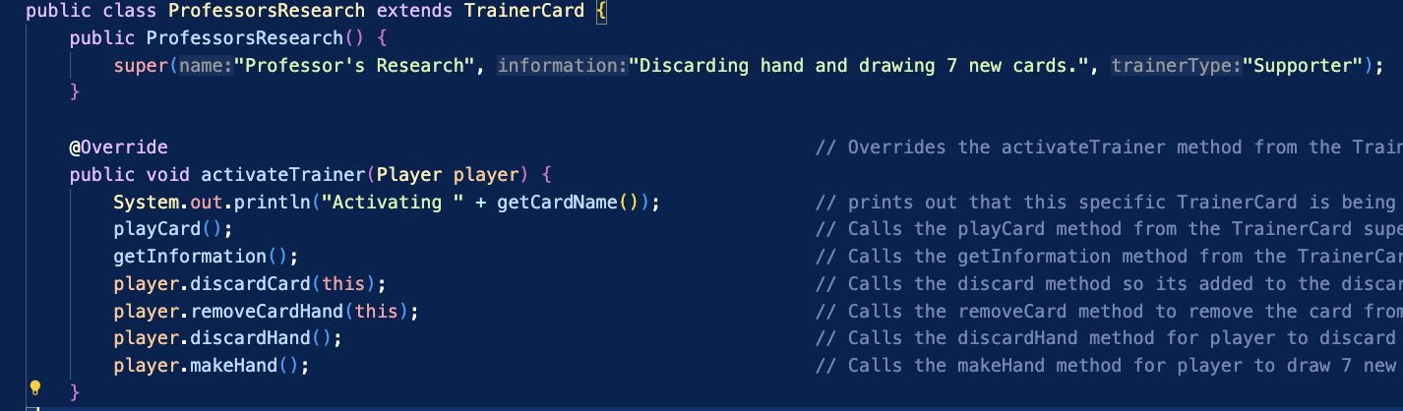

The logic Is the same for PokemonCard file, but this file contains more helper methods for its overriding methods from the PokemonGuide interface. The PokemonGuide interface contains 2 important methods which are damageEnemy and evolver, which help calculate damage and allow Pokémon to evolve. The interface also contains attackCharge method which like activateTrainer, is overridden by each of PokemonCard’s subclasses. The subclasses of PokemonCard, consisting of Pokémon like Charmander and Charmeleon, inherit methods like attackCharge to announce unique charge up declarations. One of the PokemonCard subclasses are visualized below.

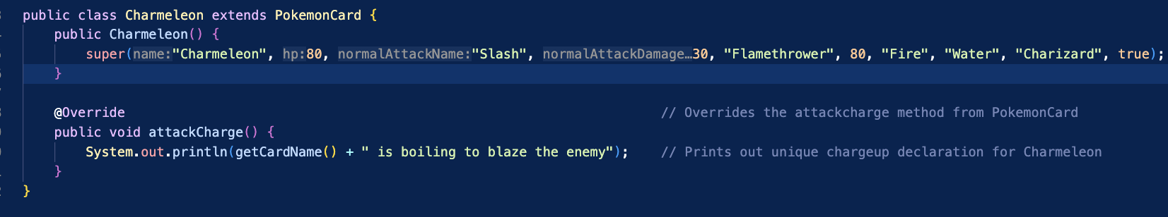

The PokemonCard class contains helper methods that compare Pokémon's types and methods to amplify/weaken attacks based on type difference. This plays into how the overridden damageEnemy is calculated, also depending on player attack choice of 1 for Normal Attack and 2 for Special Move. Below is the visualization of the damageEnemy and evolver methods.

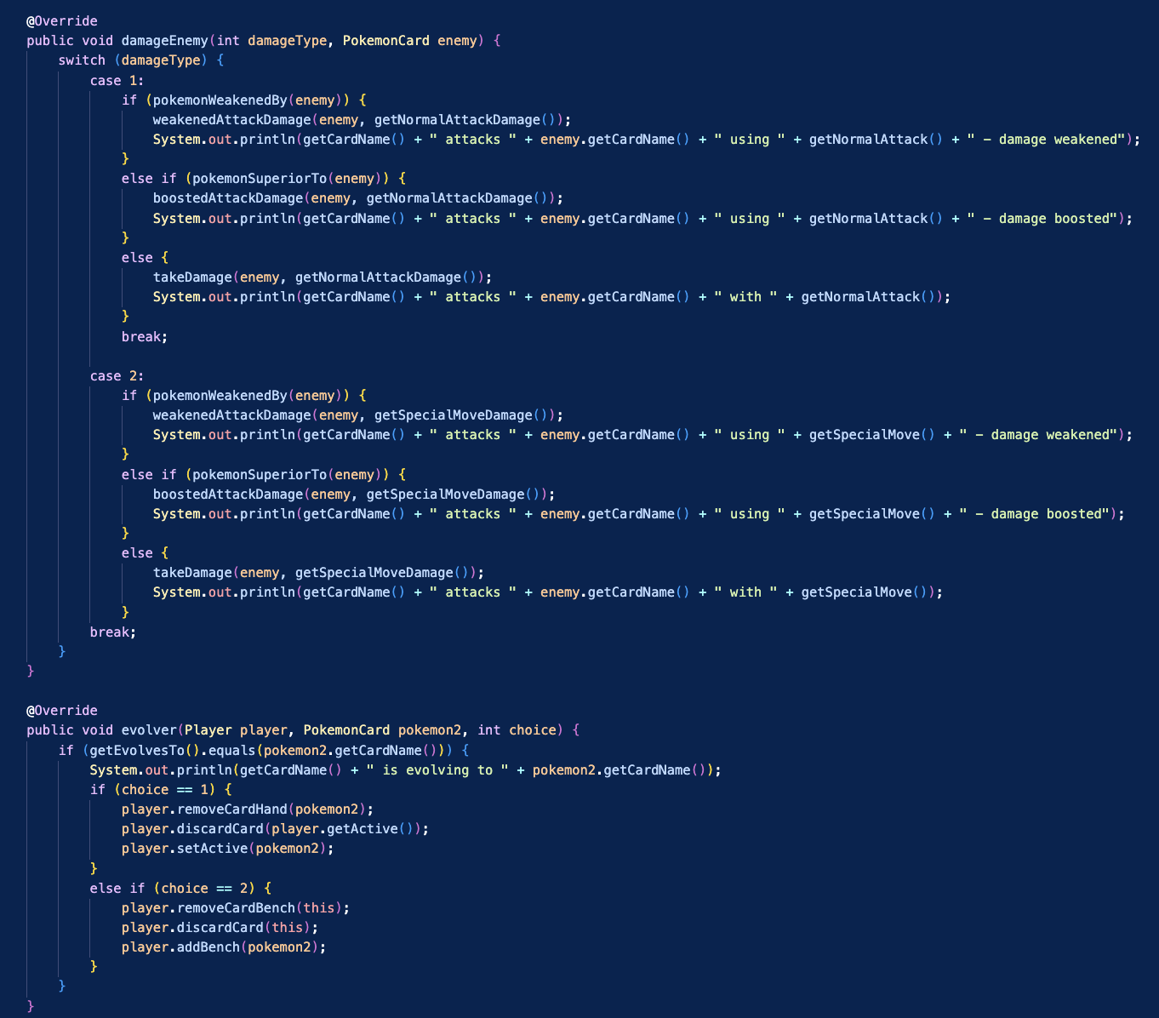

The overridden evolver method, depending on player choice of bench or Active Evolution, discards the old Pokémon and removes it from its original position effectively setting new evolved Pokémon in that position. Following is the EnergyCard class, which implements EnergyGuide interface containing the attachEnergy method which allows Active to gain an Energy matching its nature/type. The method checks if the Energy and Active types are the same then removes and adds the Energy to Active Pokémon's Energy reserve. Below is the visualization of the attachEnergy method and an EnergyCard subclass.

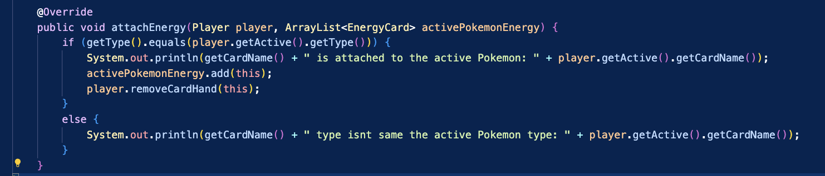 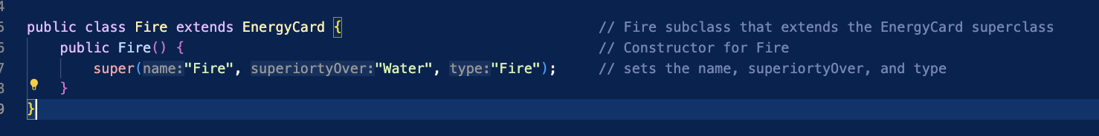

The main trio of java files which essentially create the game field and gameplay are the Deck, Player, and PokemonGameMenu files. The Deck class is very simple containing a constructor for deck with helper methods such as deckShuffler, emptyDeck, displayDeckMenu, makeDeck, etc. These methods and the constructor are created so that Player file can contain a deck in it’s constructor for gameplay. The Player file contains all player interactions with deck, hand, bench, discard pile, prize pile, and Active Pokémon. The Player java file constructor is visualized below with each ArrayList containing it’s specified type.

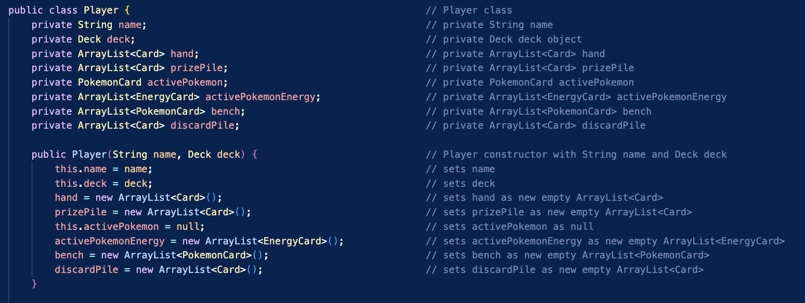

The Player class contains the basic card game field components except Active Pokémon Energy, which is an ArrayList of Energy Cards that Active depends on for attacking or Swapping/Retreating. In hindsight, Energy could have been part of the Pokémon constructor as an integer that could be incremented but I implemented it this way. This implementation restricts Energy to only Active in my program, which if developed further switching to integer Energy count would be more efficient. Player class contains multiple methods, that relate to Software checkups like Mulligan and Brick, such as makePrizePile or drawCard which addition of error checking to have consistent smooth gameplay. The most important methods for gameplay are visualized below.

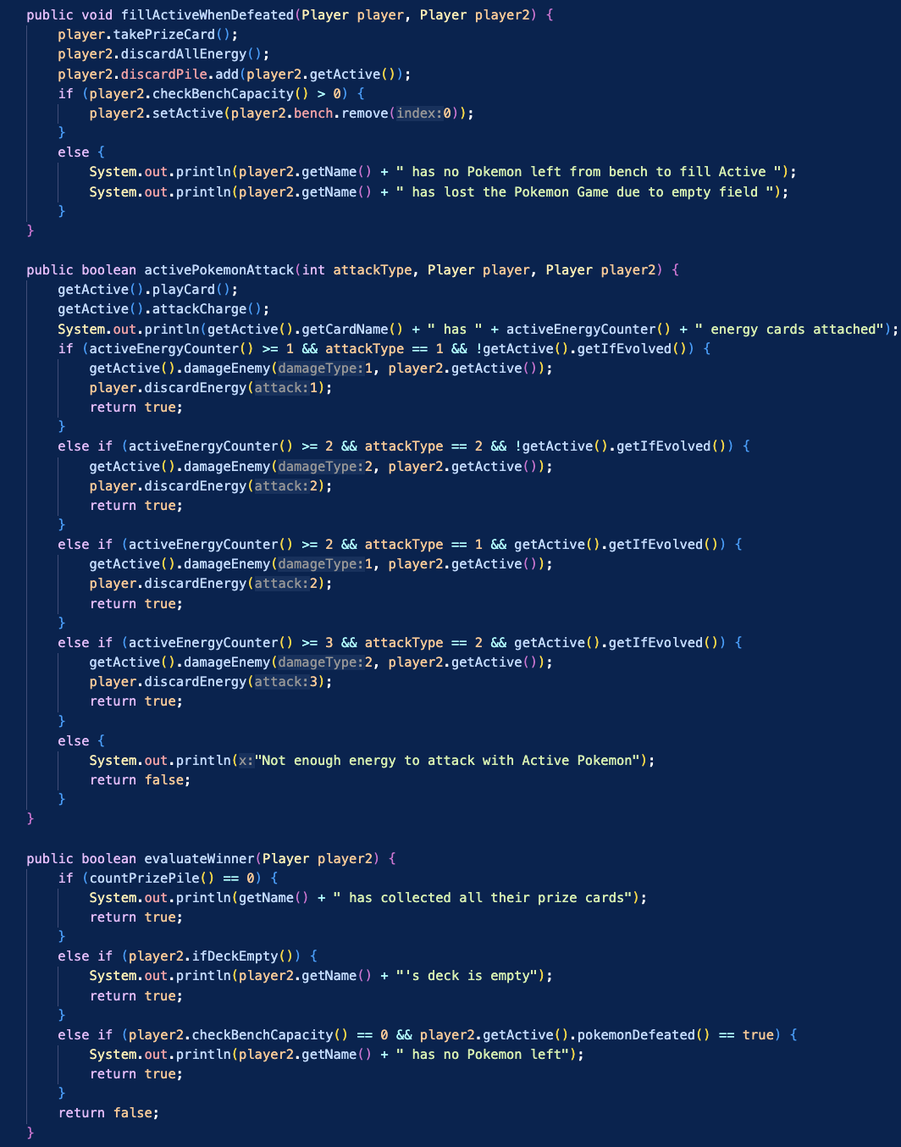

The Player class methods above are for Active Pokémon attacking, account for Evolved status and Energy count, filling Active after defeat, and evaluating the winner depending on the conditions from the Win Conditions section. The attack method utilizes the damageEnemy method from PokemonCard class to attack, and the discard energy method from player to discard exact energy after the successful attack. I was not sure if Pokémon were allowed to keep their energy after attacks, but to raise difficulty, the energy is uniformly discarded for every Pokémon. The fillActiveWhenDefeated method assures enemy Active is filled by first bench spot automatically as a safety precaution but in future development, I would streamline it to be more player choice orientated. The evaluateWinner method checks if player’s prize pile is empty first, then checks if opponent’s deck is empty, and last checks if opponent’s field is empty. These are the same Win Conditions from the previous sections and are essentially checked after end of every turn.

The final file other than PokemonGameEmulator, which runs the game, is the PokemonGameMenu containing all the game menu logic. The Game Structure section breaks down each part of the PokemonGameMenu class, starting with the Menu. The Menu uses switch case to take chosen option from the player as displayed below.

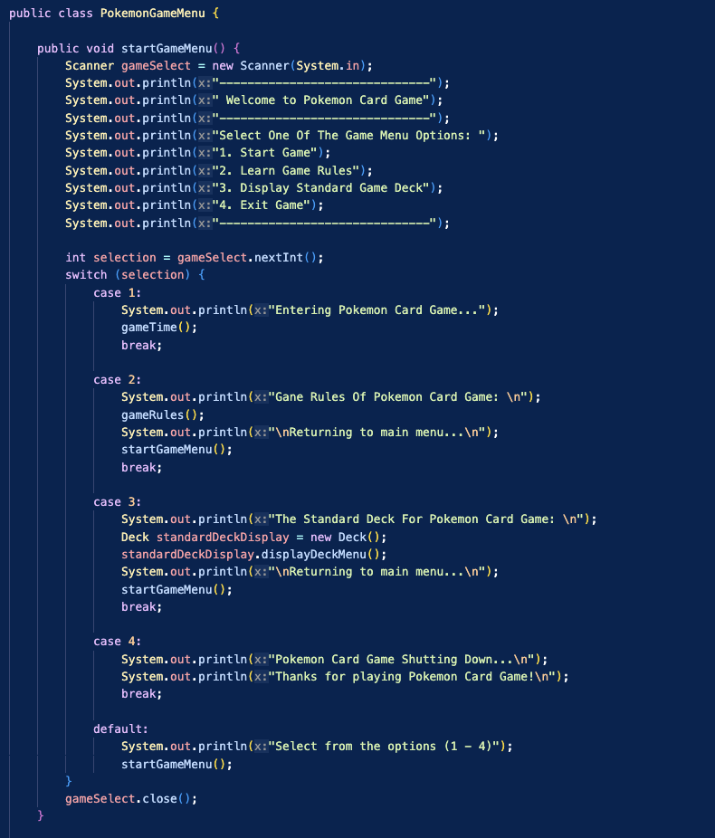

The gameTime method is next, which encompasses the entirety of the game by setting up players, flipping coin to see which player has first setup/turn, and calling the turnLoop method to start game. The format of the method is visualized below with both setPlayer and playerSetField methods.

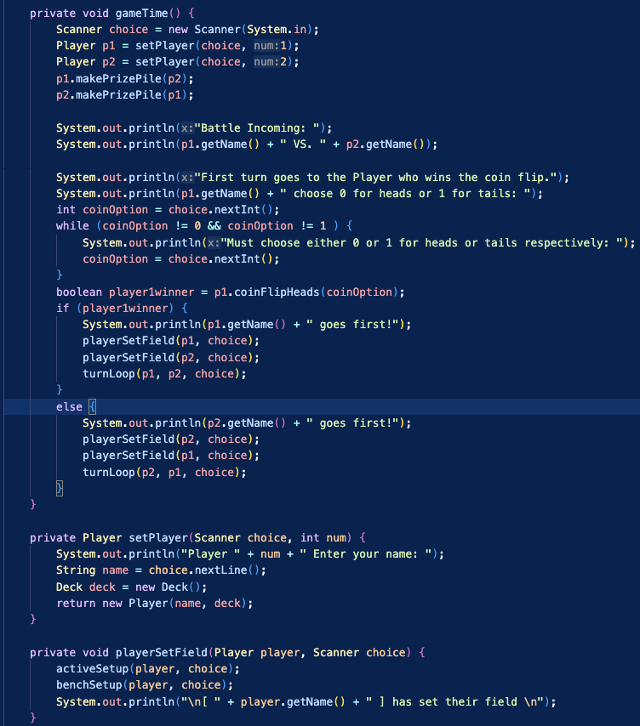

The gameTime uses the setPlayer method to create player 1 and player 2 followed by using Player class method makePrizePile to draw their hand and Prize Pile, error checking for mulligan displayed to player if it occurs. The coinFlipHeads method from Player class is used to check if player 1’s input for coin flip matches the method’s integer, which then provides the if else statement of specific player going first. If player 1 goes first they set their field, player 2 sets their field, and the turnLoop method is called with player 1 going first. If player 1 lost the coin flip, then same logic applies but player 2 would be first. The activeSetup and benchSetup methods make player choose an Active Pokémon from their hand, then optionally add up to 5 Pokémon on bench or none if player chooses. The activeSetup and benchSetup methods are visualized below with error checking to prevent wrong Card types in Active and bench.

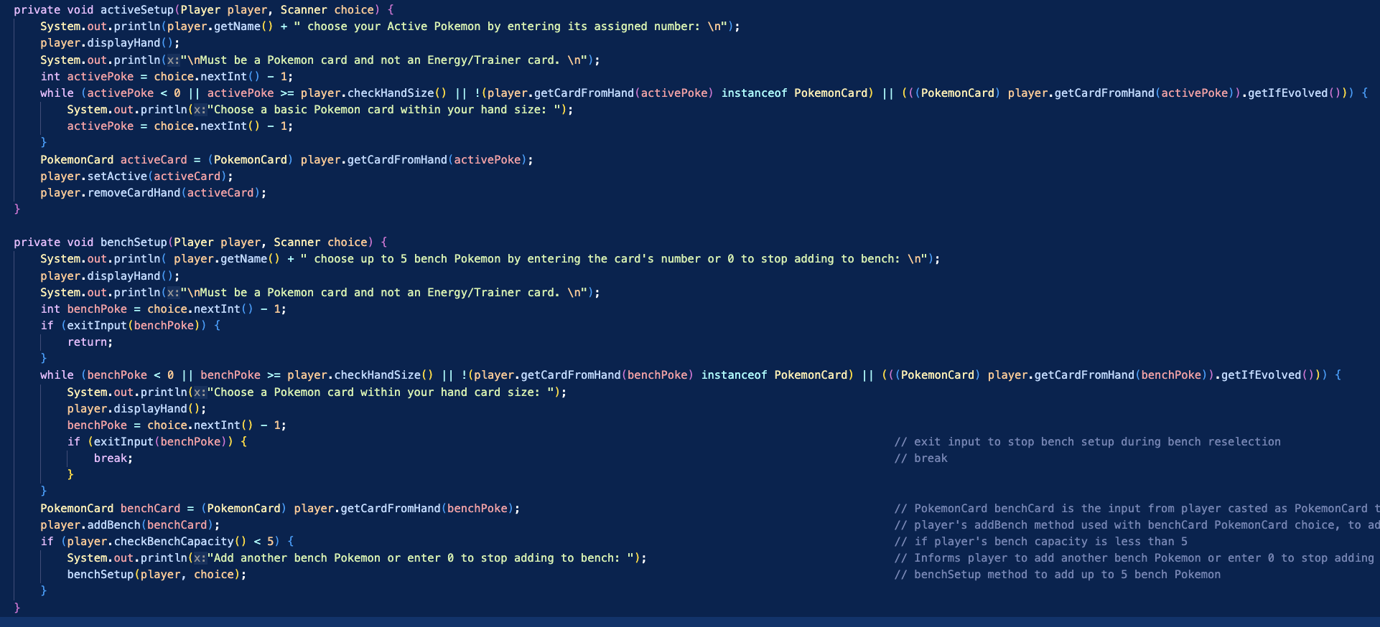

These two methods prevent anything outside the player’s hand range and non-Pokémon type Cards from being added to Active or bench. The bench, since its fully optional, allows for early exit using exitInput method in the PokemonGameMenu class. This exitInput method checks for player input of -1, the hand is shifted to 1 based index for quality and the input is shifted down 1 to match array index of hand. This exit method is used in every turn option during player turn in case of accidental input or strategy change, and the array index shifting is done for bench and hand throughout the course of the game for quality purposes. Below is the boolean exitInput method which is takes int parameter intended for player input of whichever turn option using the method.

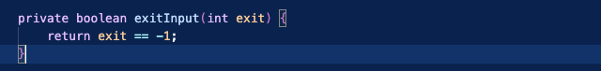

The next portion of the class is the takeTurn method containing all the logic for a player’s turn, calling methods for each turn option for organizational purposes. The takeTurn method is visualized below in multiple sections.

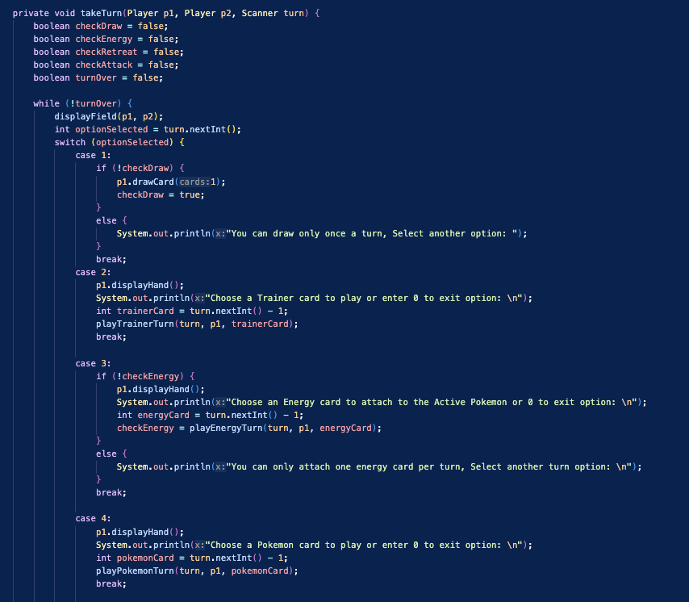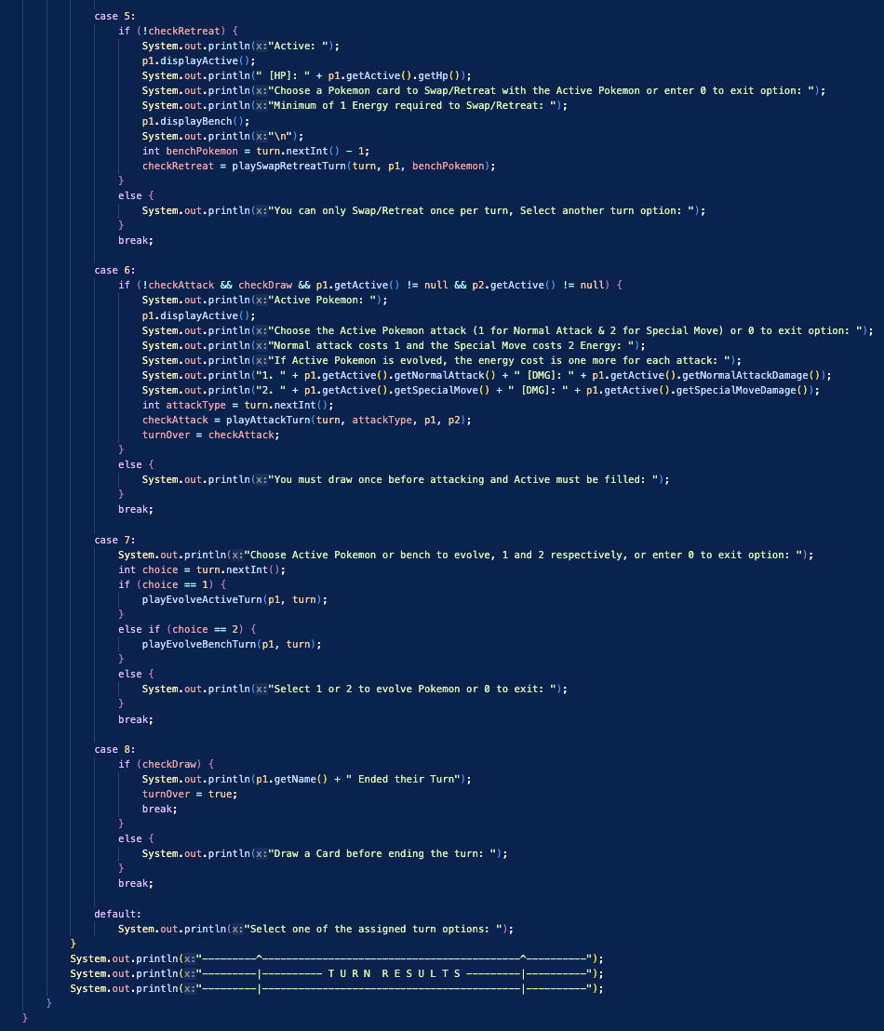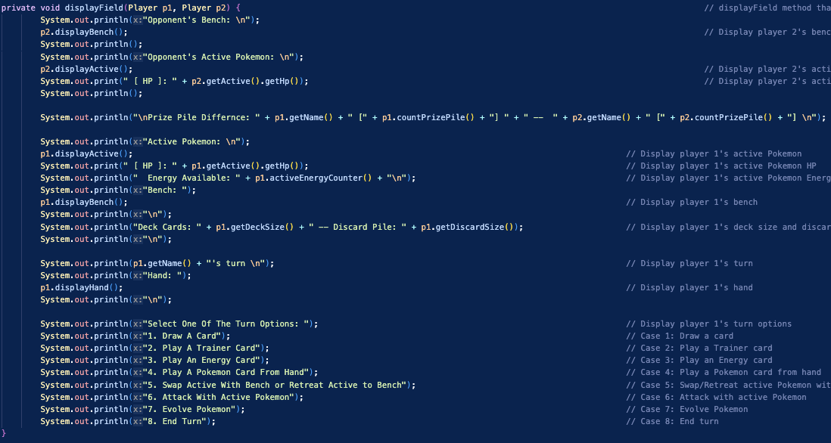

The logic behind each turn option is explained in the Game Structure section, but simply put only Draw A Card, Attack with Active Pokémon, and End Turn conflict with one another. Player cannot end their turn or attack without drawing a card and player can only draw once and attack once per turn, the attack ending turn if successful only. Player can play as many Trainers as they want and place Pokémon if there is enough space. The Player can Swap/Retreat once per turn if they have at least 1 Energy attached to their Active Pokémon. Evolving Pokémon can be done to Active and as many times as possible to bench if the evolved Pokémon is in the Pokémon's evolution line. The Attack option cannot be completed if enough Energy aren't attached, for player attack choice, and both player’s Actives must be filled. The following are the all the methods for each turn option, all of which follow similar structure but differ in casting and what methods called to complete that turn action.

**Trainer, Energy, Place Pokémon, & Swap/Retreat Options**

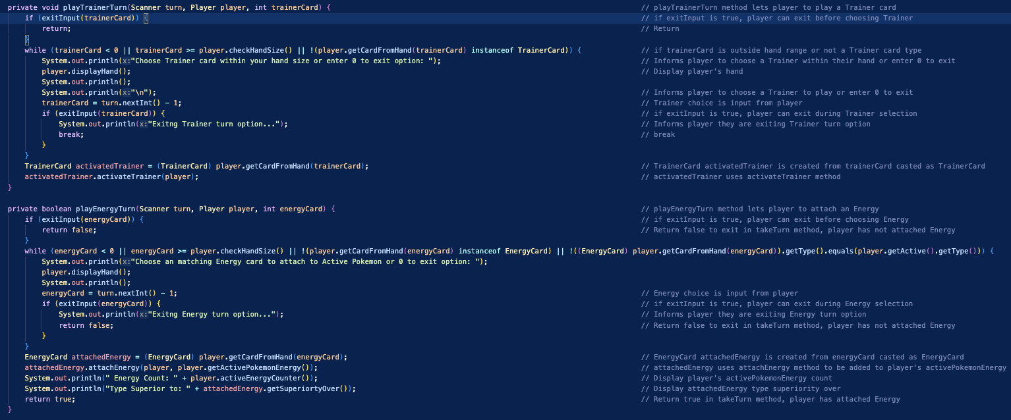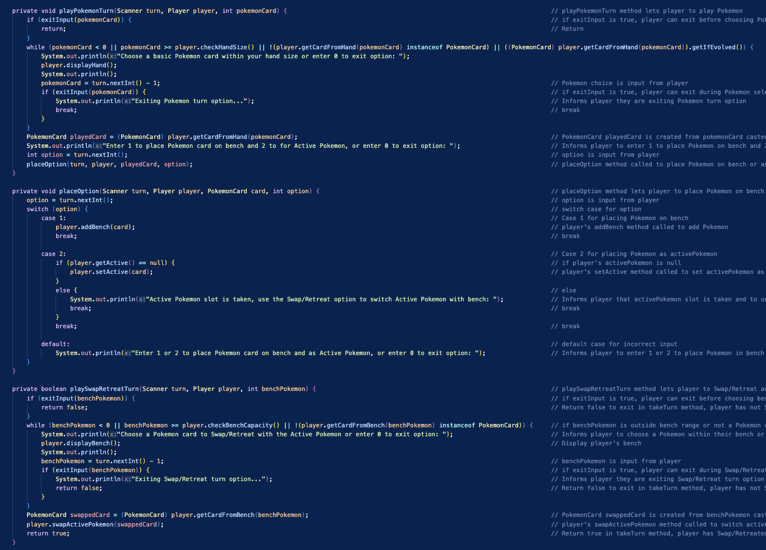

**Attack & Evolve With Active Options**

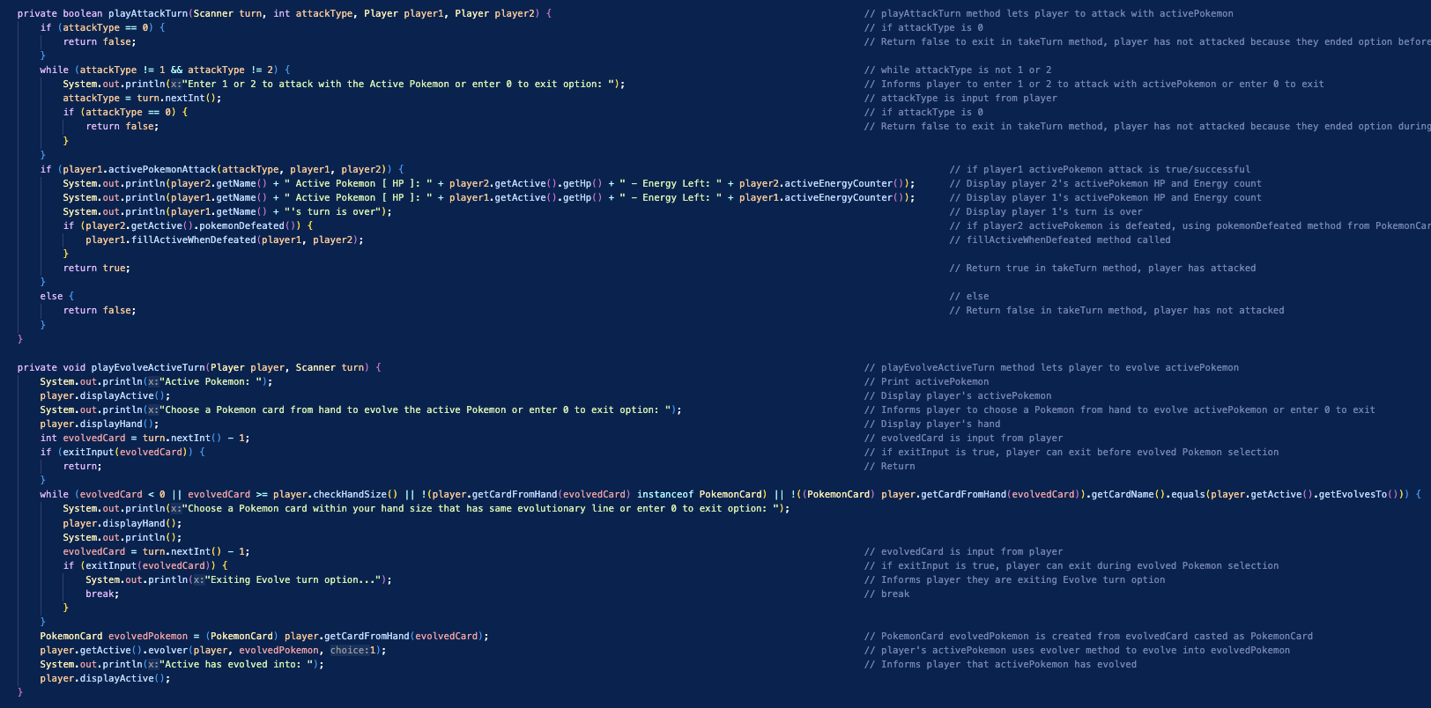

**Evolve Bench Option**

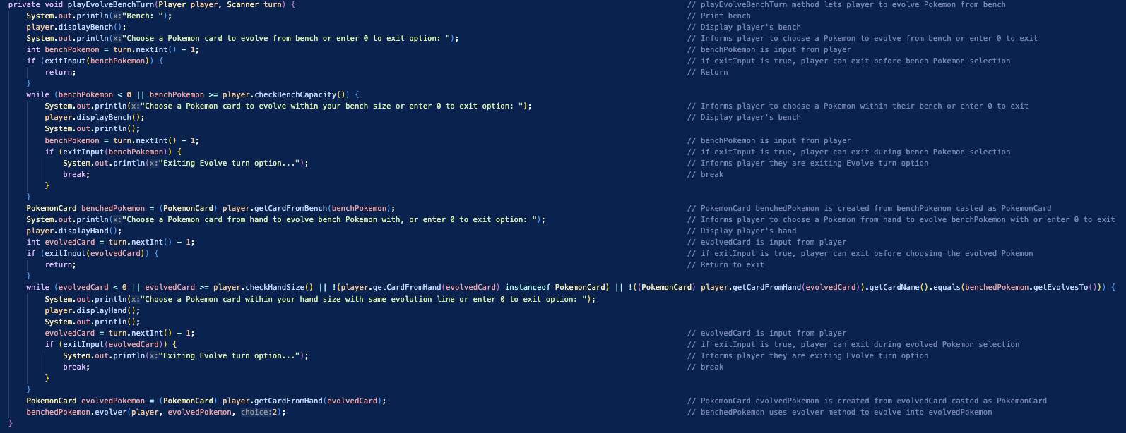

Those methods follow similar structure by first asking for player input, providing early exit using exitInput method, using while loop to rule out wrong input for the specific turn with exit option in that loop, and to cast that player input card as specified turn Card type. For example, the playTrainer method does all of the previous logic to make sure that player input can be casted as a valid Trainer card to utilize the TrainerCard method activateTrainer, which can only be done by a TrainerCard not a Card from the player’s hand. The final part of the PokemonGameMenu class is the turnLoop method which uses the Player class method evaluateWinner after end of each player’s turn, looping it until evaluateWinner is true for either player, which would break the while loop due to endgame boolean being true. The turnLoop method is visualized below at the end of the PokemonGameMenu class.

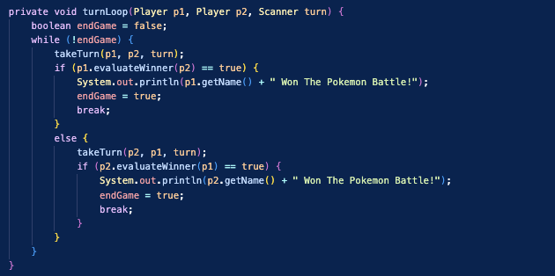

**Player Field Example**

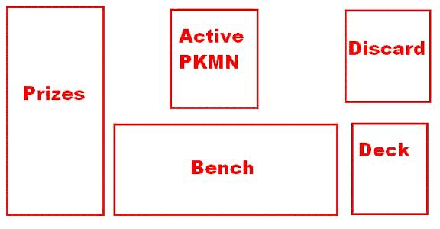

Program Additions

The Pokémon TCG Battle program has the extra credit additions of multiple Energy types, Pokémon attack based on type, and Pokémon Evolution, The Energy addition ensures Energy matches with Pokémon when attaching Energy during player turn and tells user what type its superior to. Pokémon attack based on type checks Pokémon types during attack and can either weaken or amplify the attack damage, informing player in post attack output. The final addition is Pokémon Evolution which allows for the player to evolve their Charmander to Charmeleon during their turn, adjusting/increasing attack Energy requirements. Players can evolve both Active and bench Pokémon during their turn as many times as they can. These additions make the game much more intricate and like the real-life card game played in tournaments. Although the program has its shortcomings such as Energy only can be placed on Active and Active being filled always, these additions and the error checking done help support the program’s weak points.

